

**Process Architecture Report**

Procedure to Pay - v2

# generated in 08/01/2022

**Summary**

**Process**

Procedure to Pay 4



Process Architecture

# Procedure to Pay - v2



[@ enlace para ese ítem](https://latam.interact.com.br/sa/go.jsp?to=_N3gvU01vRkFCdXVRSzluRk9uU3hFbTNKbXlYN2JlRlhJVm5vOFVTVHE0Q1JFam15OXZFRjc0SEkrUUVkOVpzdk02cTgvWi9CZUpEVG1tUDVjWkZqNTZUYzZ1anF2SUp3S2JPVVB0cFFlcWs9)



**Procedure to Pay**

*Proceso*

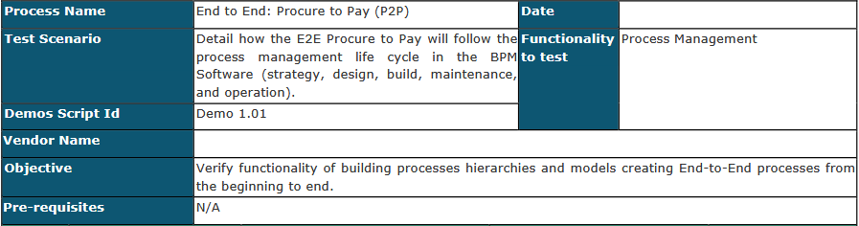

*Structure:* Unicomer / 2. Missionary Processes / Procedure to Pay - v2

*Responsable:* Sr David Agreda

*Versión:* 2 - Creado en: 21-dic-2021 0:33:48

*Stadium:* En Producción

Elements of the process

Procedure to pay



*Description:*

Pool

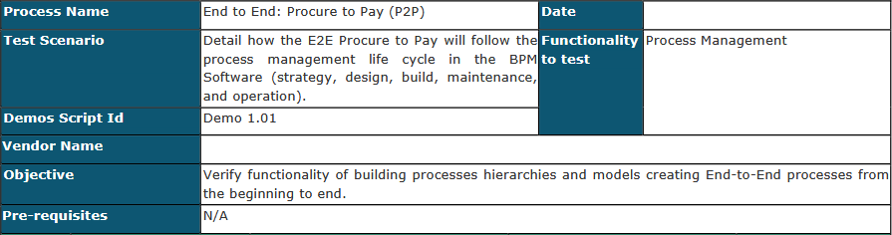

*Linked Ítems:*

 *Constructora Millenium*

 *Mejorar la eficiencia adminsitrativa * *Procesos Internos*

 *Sector de Compras*

## Applicant

Raya

*Descripción:* Which is performed by a store.

## Analyst

Raya

*Descripción:* Analyst who will make a decision on the purchase request.

## Purchases

Raya

*Descripción:* This is the purchasing area of the company.

## 0. Inicio

Evento de Inicio

*Rol:* Público

*Descripción:* Initial activity of the process

## 1. Request Purchase

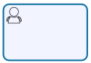Actividad Normal

*Rol:* Público

*Prioridad:* Normal

*Descripción:* Any company store can, through this step, initiate a request for the purchase of material or service.

*Ítems Vinculados:*

 *OR-01 - Wrong Product / Service Identification*

## 2. Greater than $ USD 300?

Gateway Exclusivo



*Descripción:* Decision if this greater than $ USD 300

*Condiciones:* Yes -> Analyze request

Not -> Material / service purchases

## 3. Analyze request

Actividad Normal

*Rol:* Analyst

*Descripción:* Who is going to verify why the purchase is greater than 300 USD and give their authorization if it is approved or rejected.

*Prioridad:* Normal

*Descripción:* The analyst reviews the purchase request and chooses whether to approve, return, or reject.

## 4. Decision

Gateway Exclusivo

*Descripción:* Process rule, where it is decided which activity will continue based on the analyst decision.

*Condiciones:* Approved -> Material / service purchases

Rejected -> Notify Rejection

Verify Request -> Request Purchase

## 5. Material / service purchases

Actividad Normal

*Rol:* Purchases

*Prioridad:* Normal

*Descripción:* It is made to make the purchase of the products requested by a store.

*Ítems Vinculados:*

 *Auditoria ISO 9001:2015*

 *OR-02 - Purchase of the correct order quantity*

## 6. Notify Rejection

Evento intermediaro de Envío de Mensaje

*Descripción:* The rejection is notified to the store.

*Destinatarios:* Para:${email}

*Título:* Purchase Request Rejected

*Mensaje:* Dear: ${solicitante}

Your purchase request No. ${@parentSerial} regarding the product ${product} has been rejected for the following reasons:

${justify_aprob}

If you wish, you can generate a new request. Cordially:

Purchasing Management Interact Solutions

## 7. End

Evento de Fin Terminal

*Descripción:* Actividad Final del proceso

## 8. Receive Material / Service

Actividad Normal

*Rol:* Público

*Prioridad:* Normal

*Descripción:* The applicant receives the material or service.

*Ítems Vinculados:*

 *Auditoria Determinacion y Clasificacion de los Requerimientos de Producto * *OR-03 - Evaluate the product / service according to quality standards*

 *OR-04 - Loss of Merchandise*

## 9. End

Evento de Fin Terminal

*Descripción:* End

## 16. Group Unicomer

Imagen

*Descripción:* Business logo

## Anexos del Proceso

*BPM_System_Demo_Script 16.12.21.pdf*

Versiones

*Nombre*

*Fecha*

*Responsable*

*Estadio*

V1 - Procedure to Pay 03-dic-2020 13:04:33 Sr David Agreda Archivado

V2 - Procedure to Pay 21-dic-2021 0:33:48 Sr David Agreda En Producción V3 - Procedure to Pay 08-ene-2022 10:15:50 Sr David Agreda En Modelado

